**Inheritance – Notes**

Principle of segregation – As offspring are formed by the inion of a male and female gamete, each offspring receives one gene from each characteristic of each parent cross.

Dominant trait: The trait/allele that masks the recessive trait; represented by a capital letter.

Recessive trait: The trait/allele that’s masked by a dominant trait; represented by a lowercase letter.

Genotype: The shorthand way of representing which 2 traits/alleles for a particular gene an individual has e.g., Bb, BB, bb – the allele combination for a gene.

Phenotype: The physical expression of an individual which results from a particular genotype (composition of genes) e.g., blue eyes.

Gene: The factor that determines an inherited characteristic (located in the chromosomes).

Allele: Alternative forms of a gene; individual receives one from mother and one from father.

Heterozygous: An organism that carries 2 different alleles for the same gene e.g., Bb.

Homozygous: An organism that carries 2 copies of th same allele for a particular gene e.g., bb or BB (purebred).

Mendel’s law 1 – Principle of segregation:

For any particular trait, the pair of alleles of each parent separate and only one allele passes from each parent onto an offspring. The allele that’s inherited from both parents is a matter of chance. This segregation of alleles occurs during meiosis.

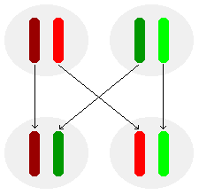

Mendel’s law 2 – Principle of independent assortment:

Each gamete receives only one set of genes. The other set goes to the other gamete. Note: During Meiosis I, tetrads can line up in 2 different ways before the homologs separate.

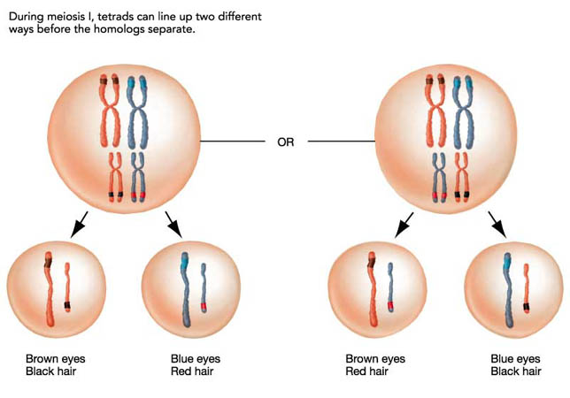

Monohybrid cross: A trait (characteristic) determined by only one pair of alleles.

First filial generation: The first generation of offspring produced by 2 parents in a genetic study.

Second filial generation: The second generation of offspring.

Dihybrid cross: A trait determined by 2 or more pairs of alleles.

Punnett squares are used to determine the probability of characteristics in offspring.

|  |  |  |
| --- | --- | --- |
|  | y | y |
| Y | Yy | Yy |
| y | yy | yy |

Sex determination:

* 50% male gamete (sperm) carries the Y chromosome or the X chromosome.
* 100% chance female gamete (ovum) carries the X chromosome.
* Gender determined by which sperm fertilizes the ovum (50% chance male or female offspring).

Sex-linked inheritance occurs when the genes (alleles) for a particular trait are located on the sex chromosomes.

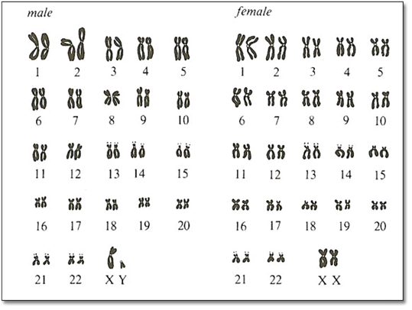

X-linked inheritance:

* Genes that are carried on the X chromosome are known as X-linked.
* Females therefore can have 2 alleles for the gene, males will only have one allele for the gene.
* This means that males are more likely to acquire an X-linked hereditary disorder and can never be carriers (heterozygous).
* Males can’t be homozygous either. They’re hemizygous.

Y-linked inheritance:

* Very rare and carried on the Y chromosome.
* Impossible for females to ave the gene.
* e.g., hairy ears.

Codominant inheritance:

* When the 2 alleles coding for a particular trait are neither dominant or recessive over the other.
* When they combine, the phenotype is a form of patches of the 2 rather than one masking the other.

Incomplete dominance:

* With incomplete dominance, a cross between organisms with 2 different phenotypes produces offspring with a third phenotype that’s a blending of the parental traits.

Autosomal recessive:

* Can skip a generation.
* Carried on recessive autosomal allele.

Impossible:

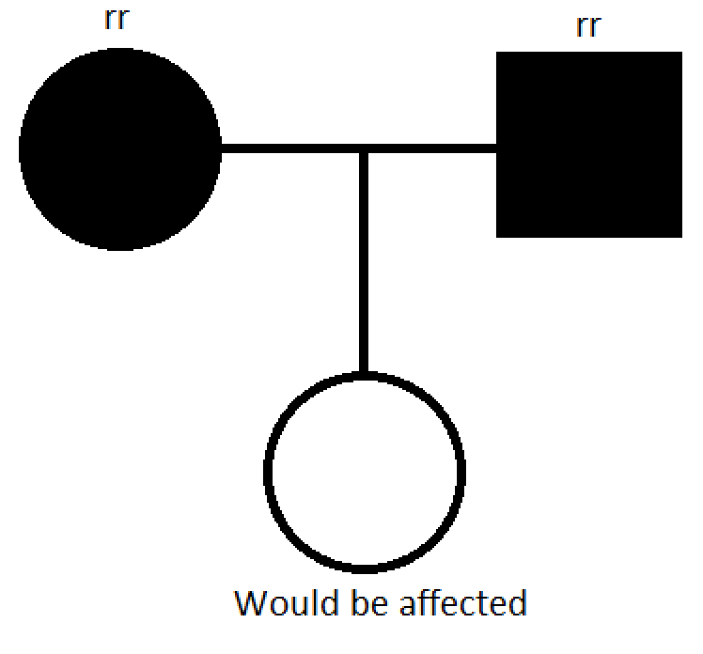

Possible:

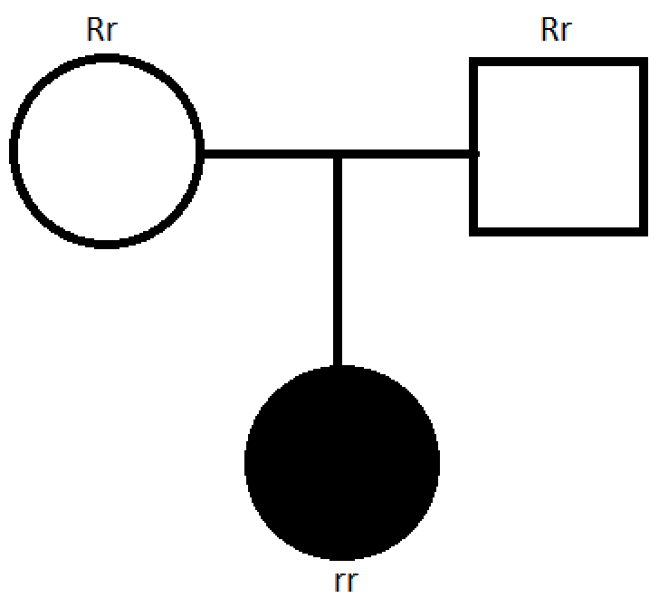

Autosomal dominant:

* Unlikely to skip a generation.
* Carried on the autosomal dominant allele.

Impossible:

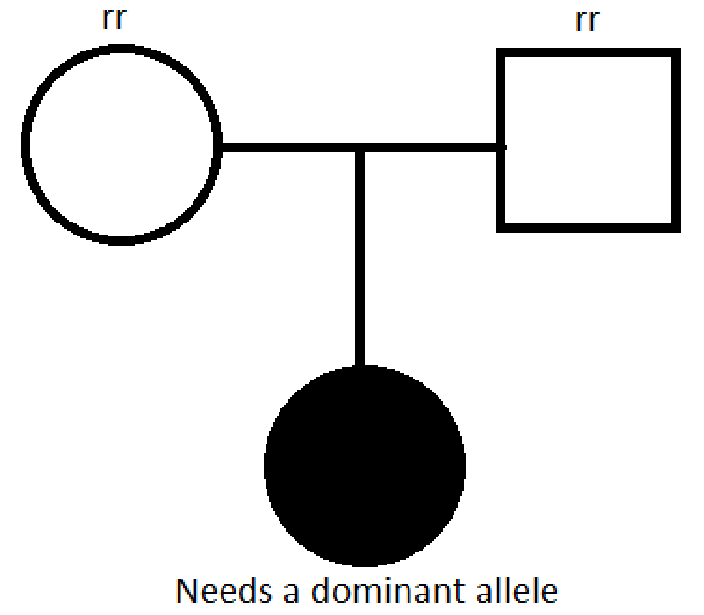

Possible:

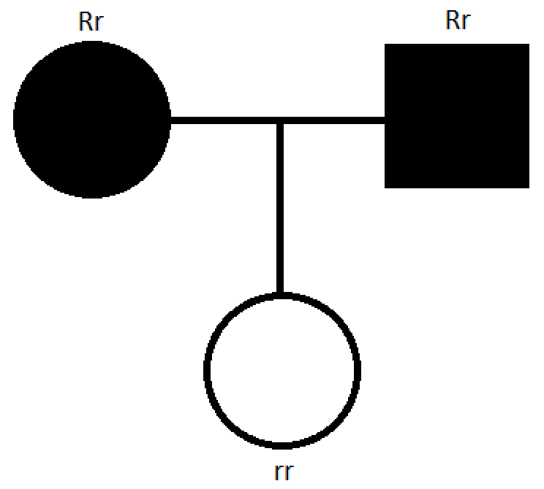

X-linked recessive:

* If a mother has the condition, all sons will have the disease regardless of whether the father has it or not.

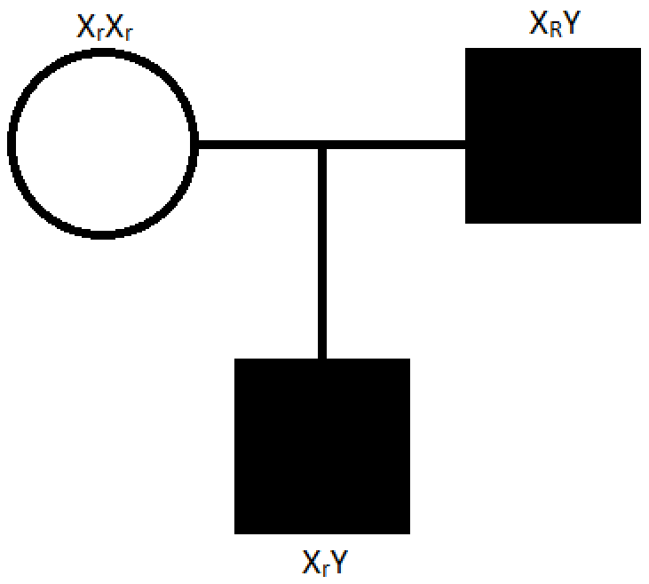

X-linked dominant:

* Affected fathers all have affected daughters regardless of whether the mother has it or not.

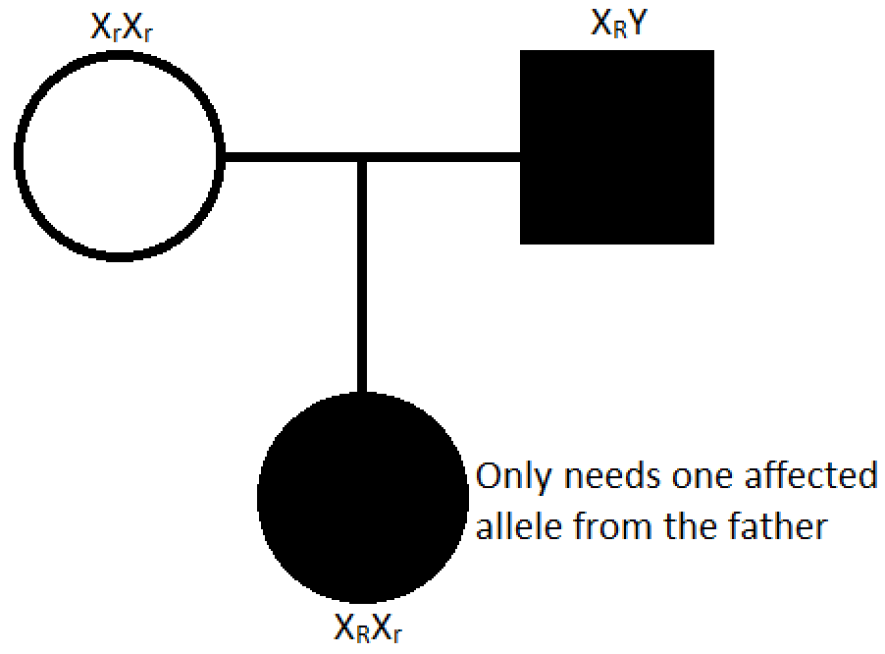

|  |  |
| --- | --- |
| **Blood group**: | **Possible genotypes**: |
| A | IAIA or IAi |
| B | IBIB or IBi |
| AB | IAIB |
| O | ii |

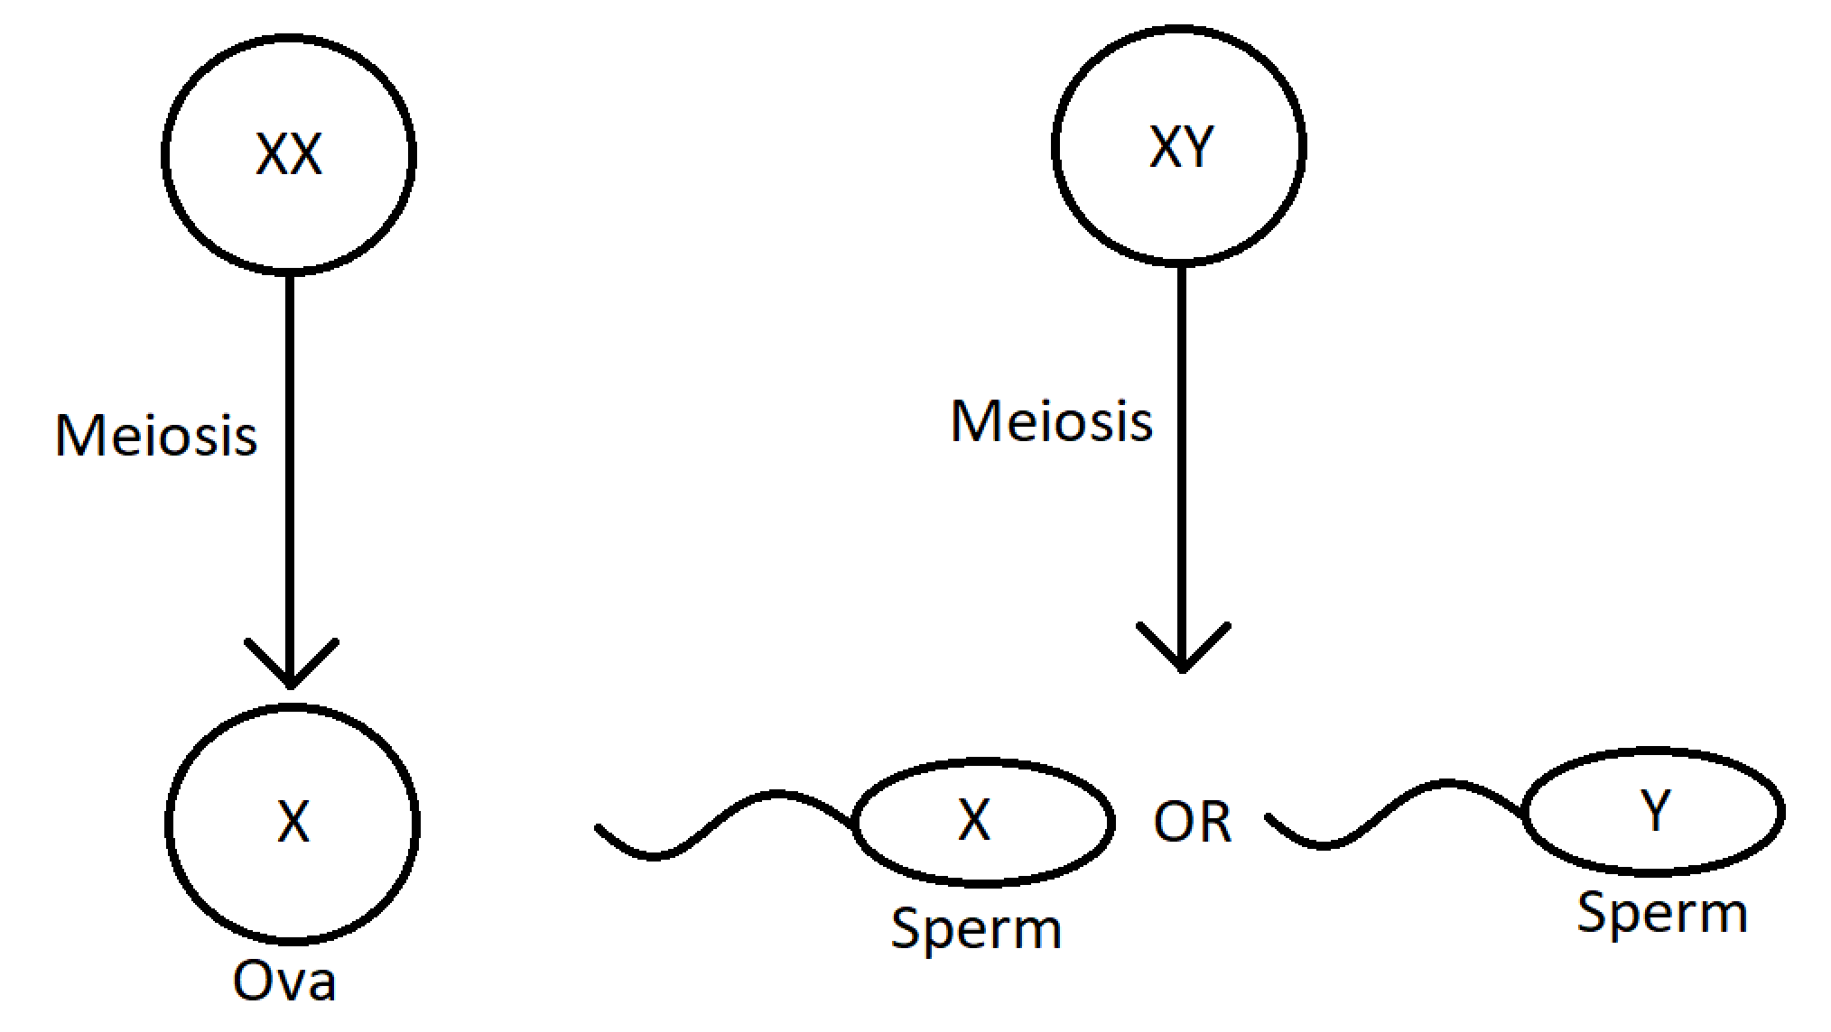

Q: How is the sex of a person determined at conception?

Females have 2 X chromosomes in each somatic cell and males have one X and one Y chromosome in each somatic cell. When meiosis occurs in the ovaries, the ova all contain one X chromosome. When meiosis occurs in the testes, 50% of the sperm contain a Y chromosome and 50% contain an X chromosome. There’s an approximately equal likelihood of an X-carrying sperm or a Y-carrying sperm meeting the X-carrying ovum. Hence, there’s a 50% chance of an XY or XX zygote.